Development Setup

Step1 create workspace

e.g., mkdir work

cd work

Step 2: make sure you have git command line tool and run below command

git clone -b alpha --single-branch <https://github.com/rnagulapalle/springweb.git>

Step 3: cd into springweb and make sure you are pointing to origin/alpha by running git status

Step 4: git checkout (this is not needed)

Step 5: follow below steps to import your project into Eclipse

1. Open eclipse pointing to above work space directory.
2. Import project

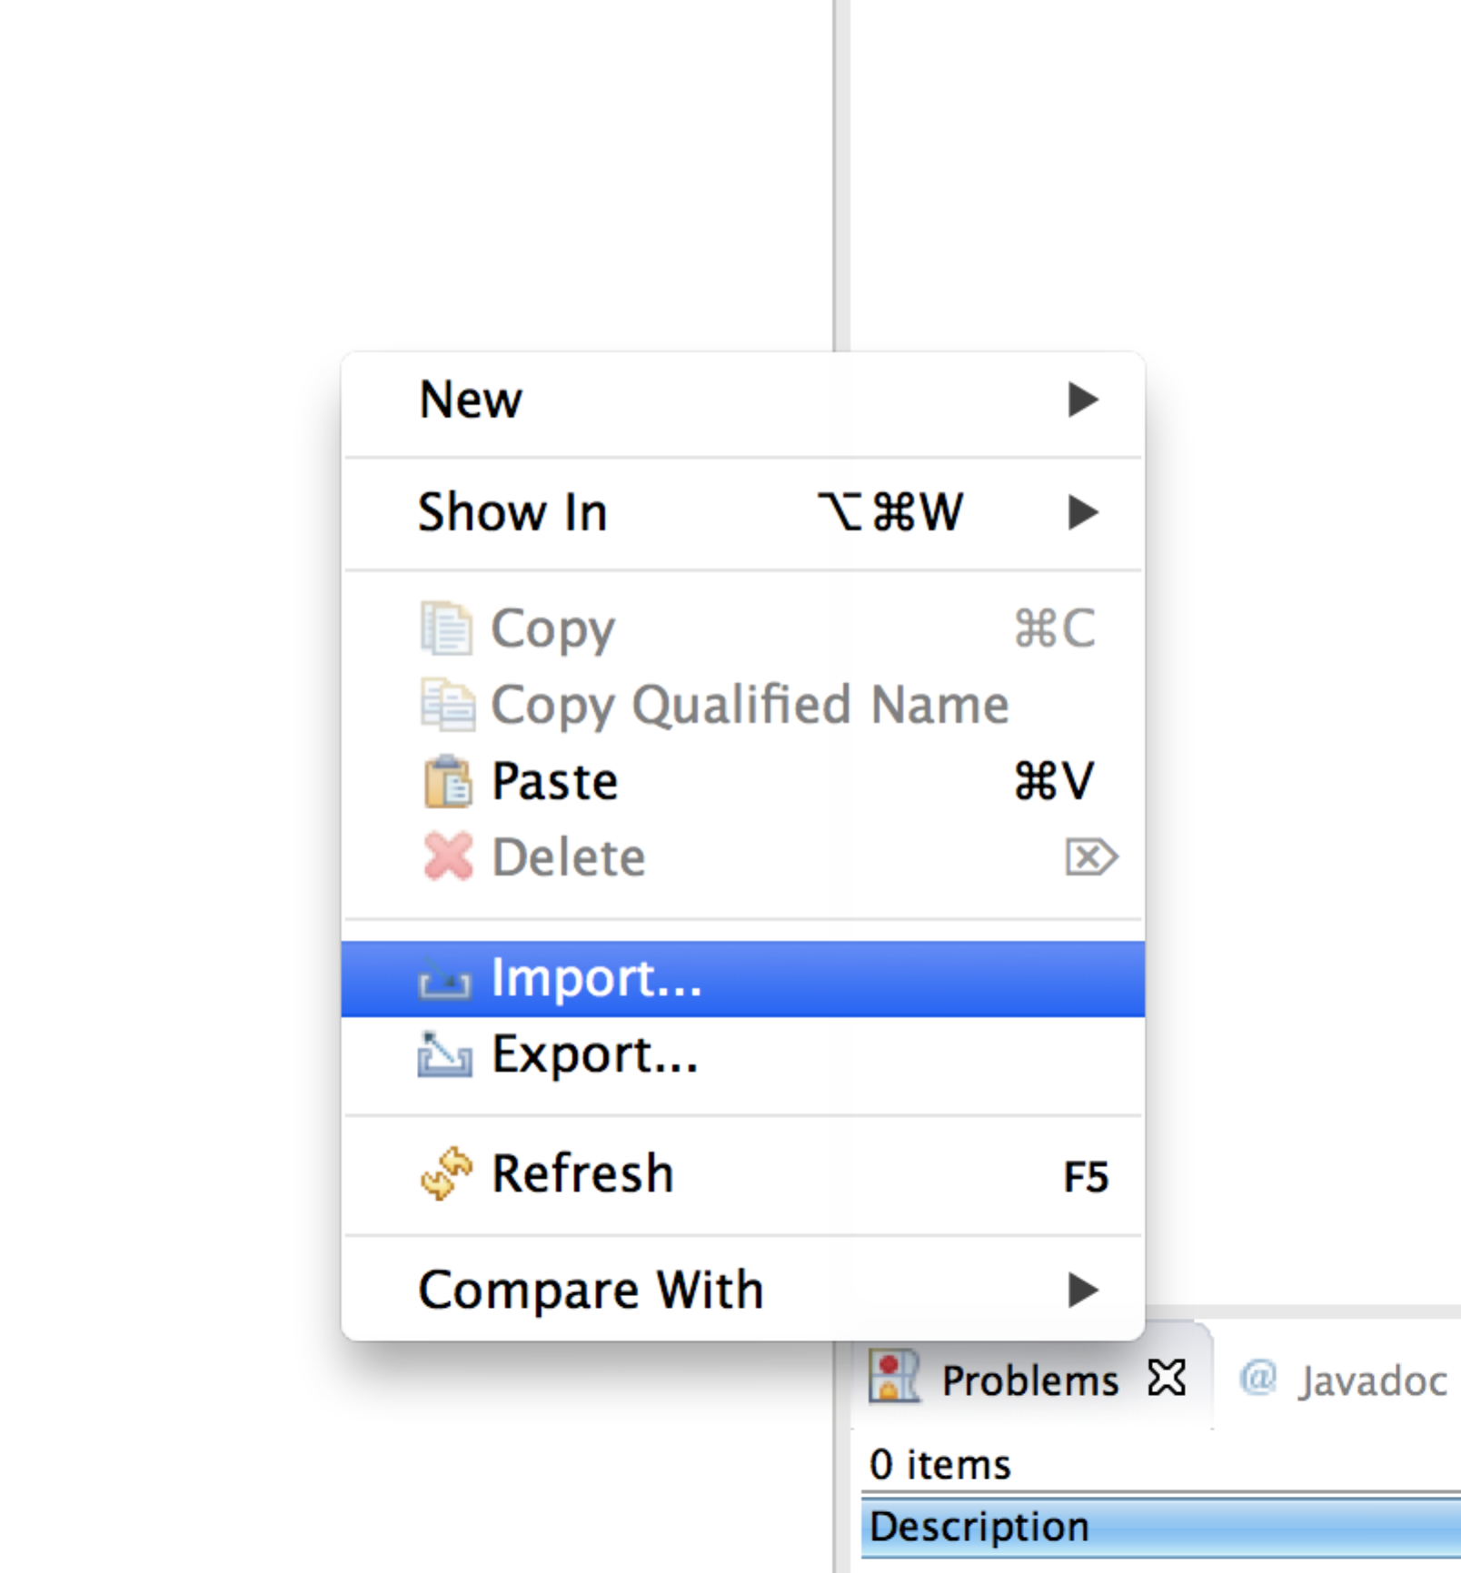

Select Project from GIT

1. 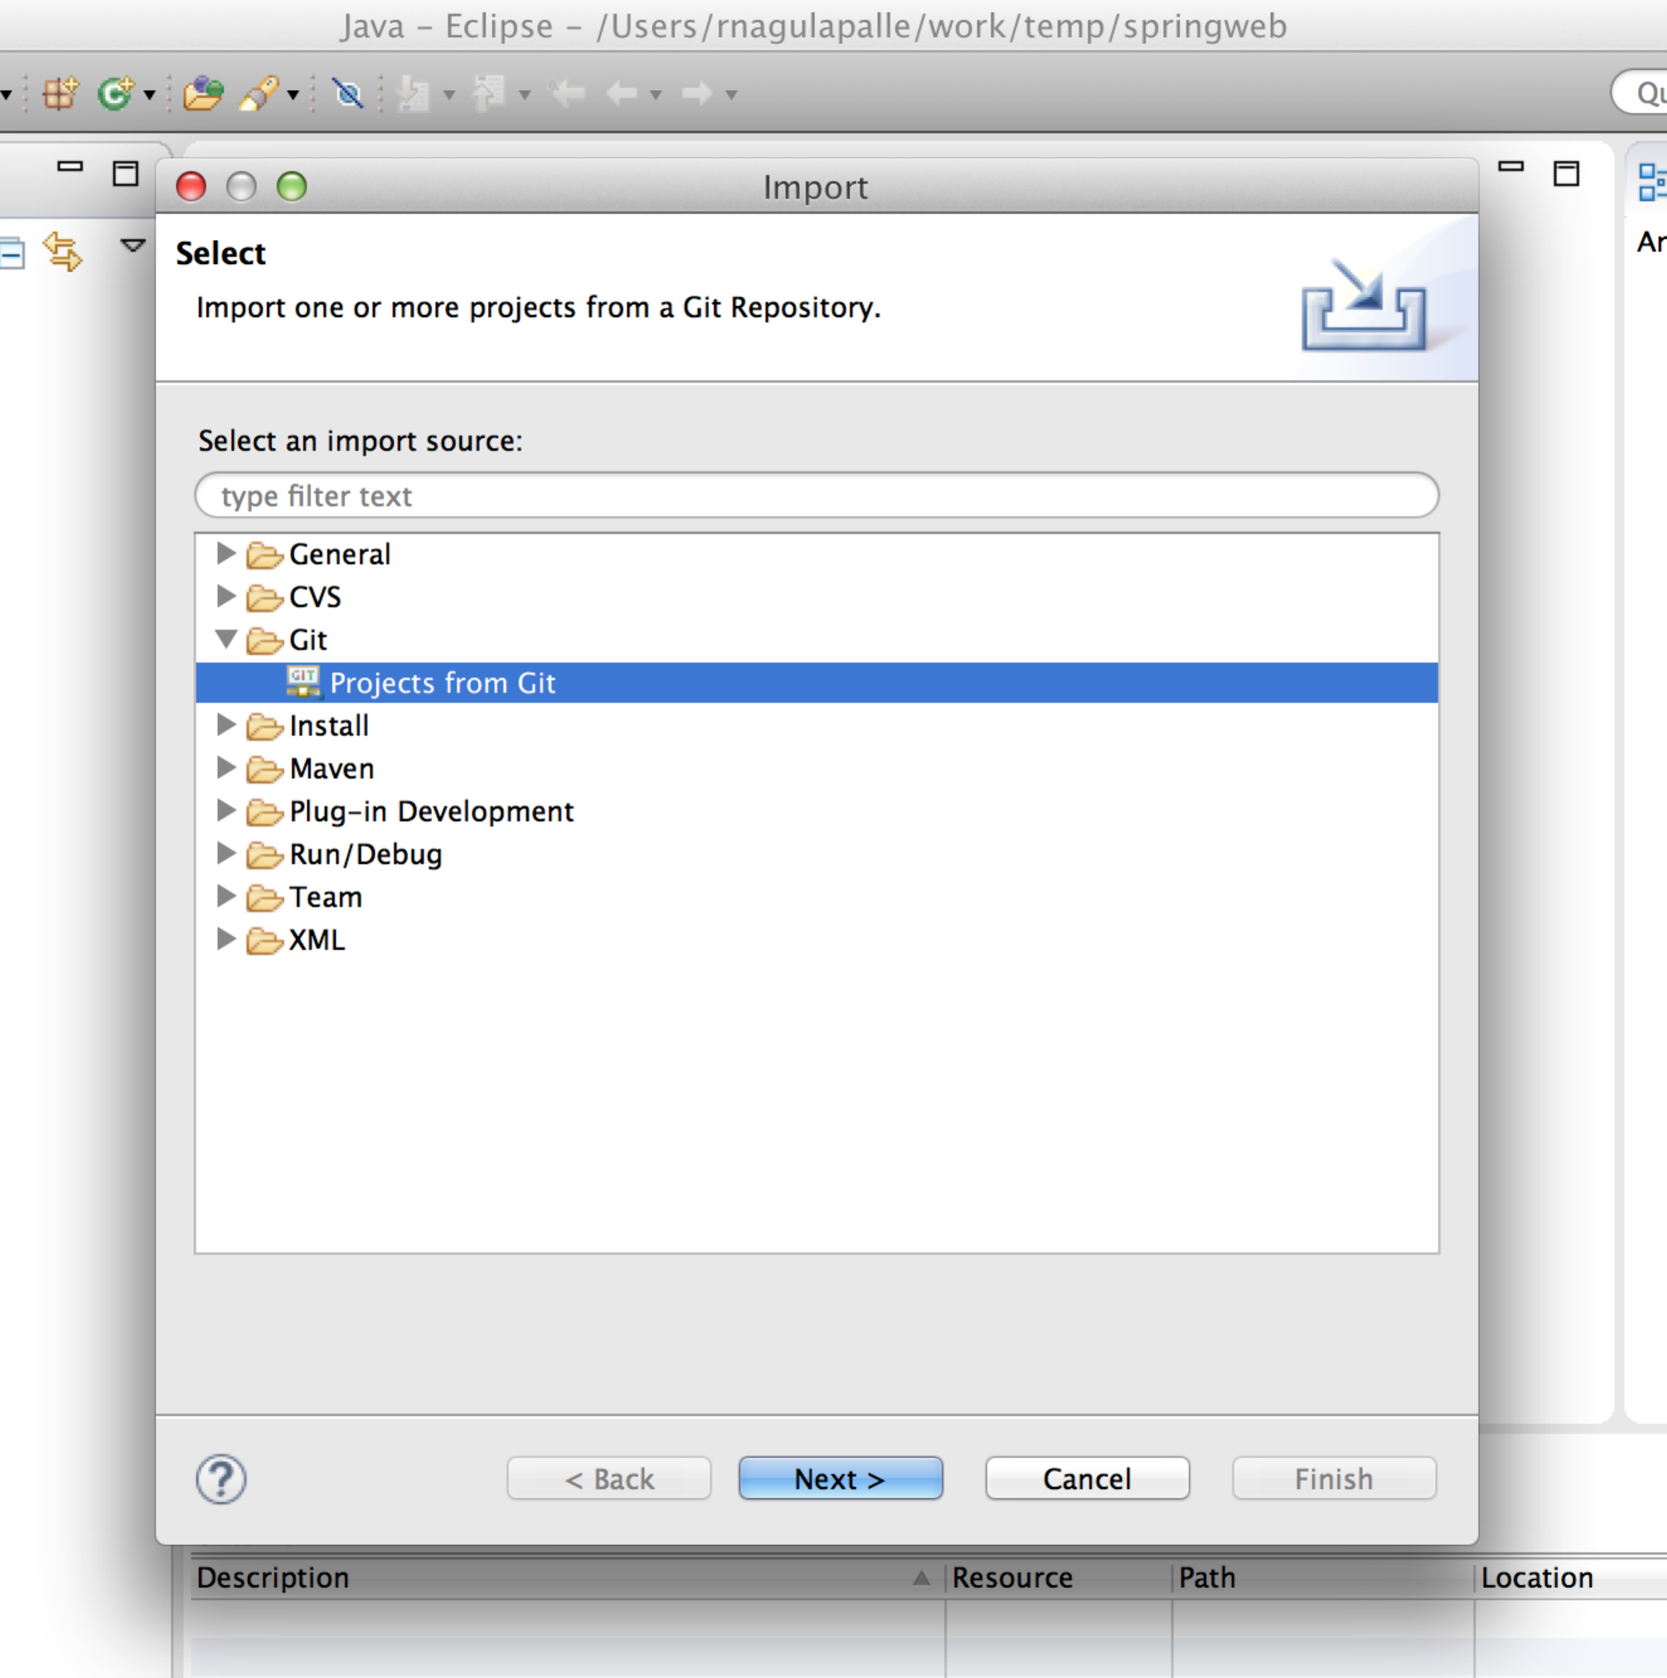
2. 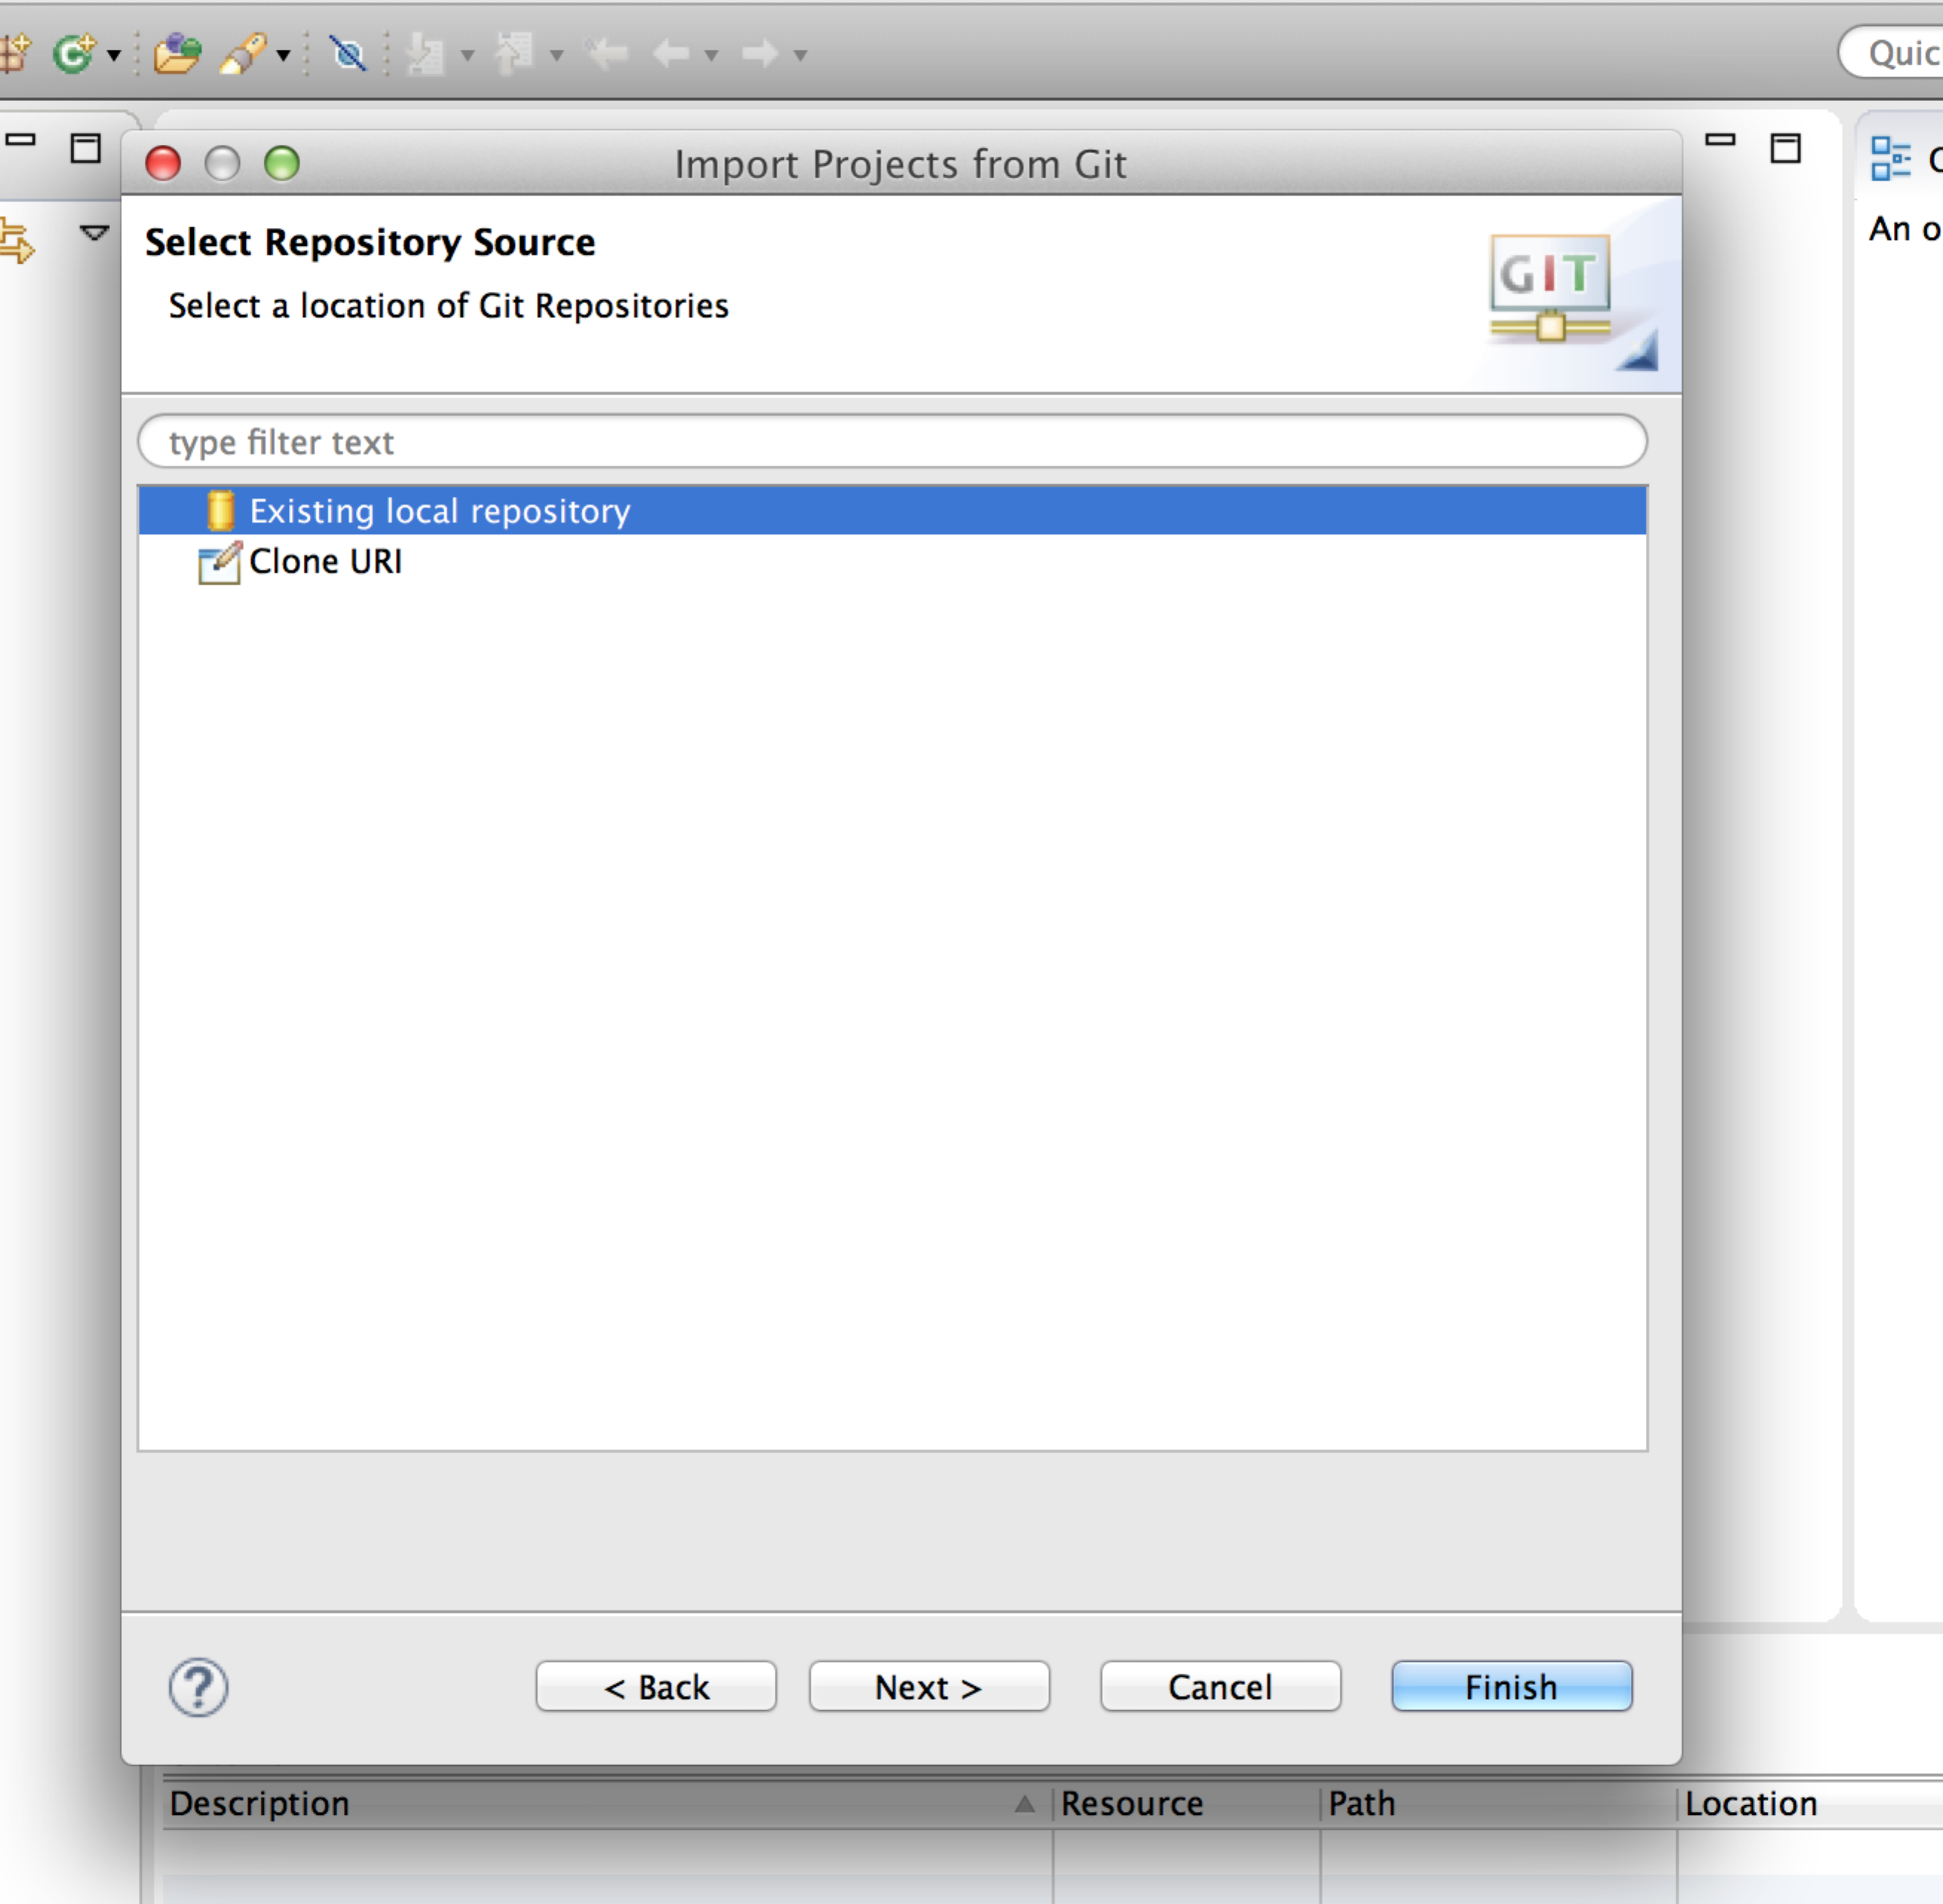
3. 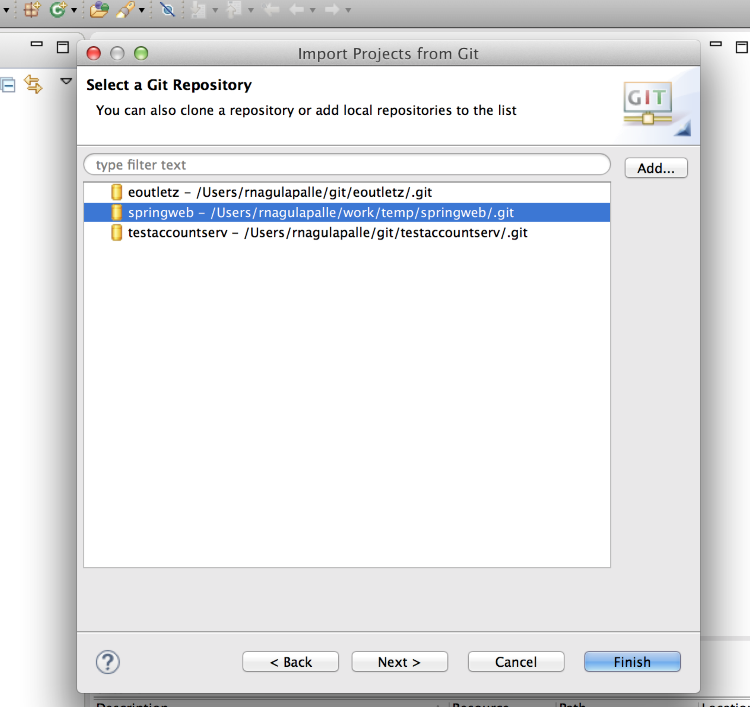
4. 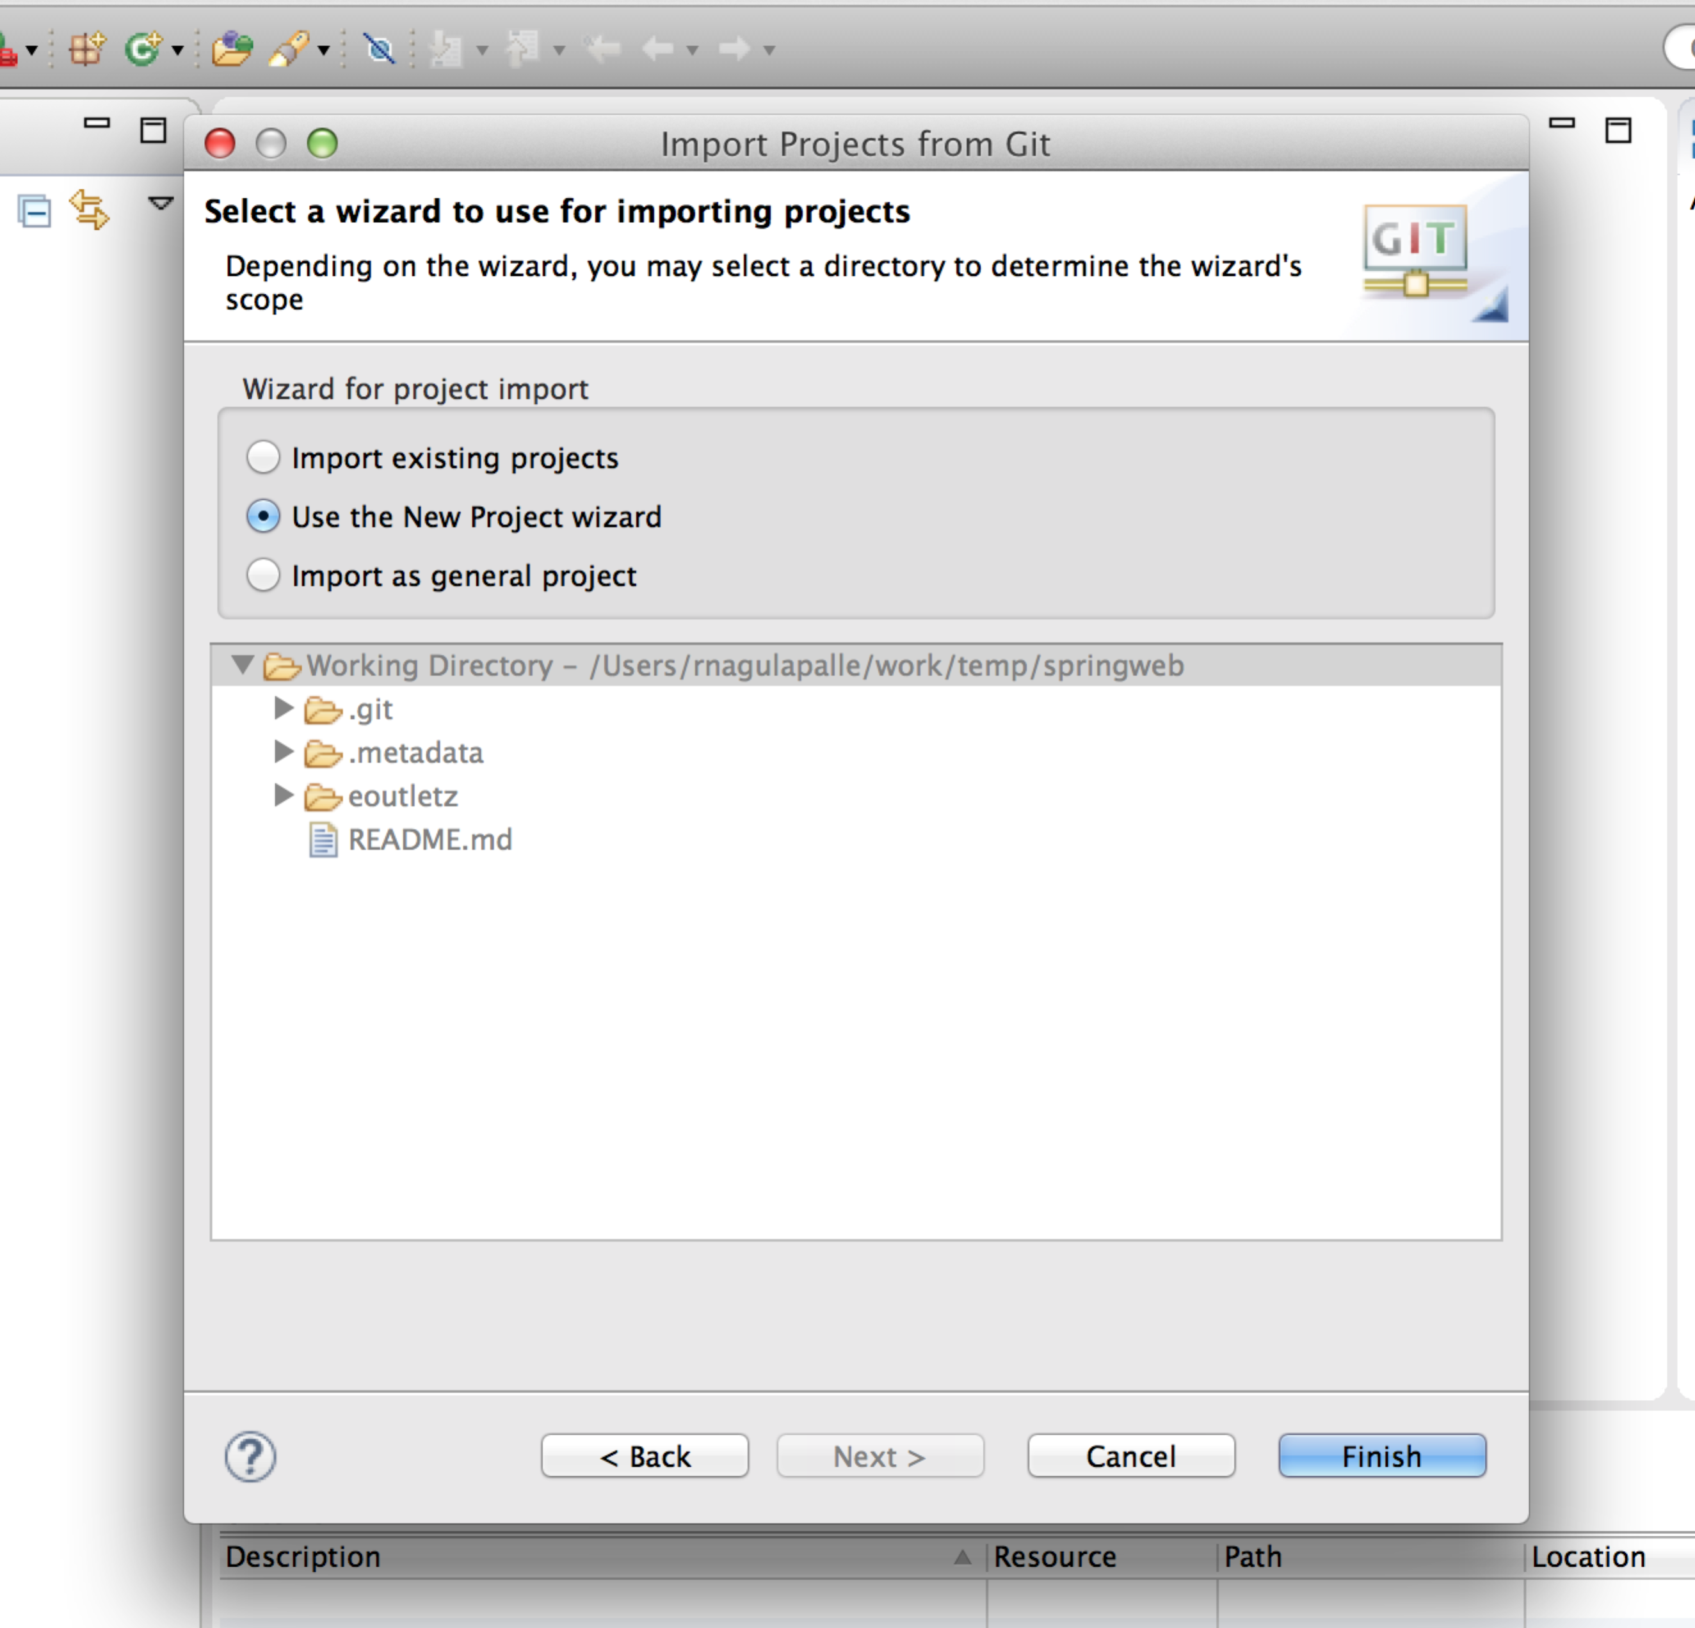
5. 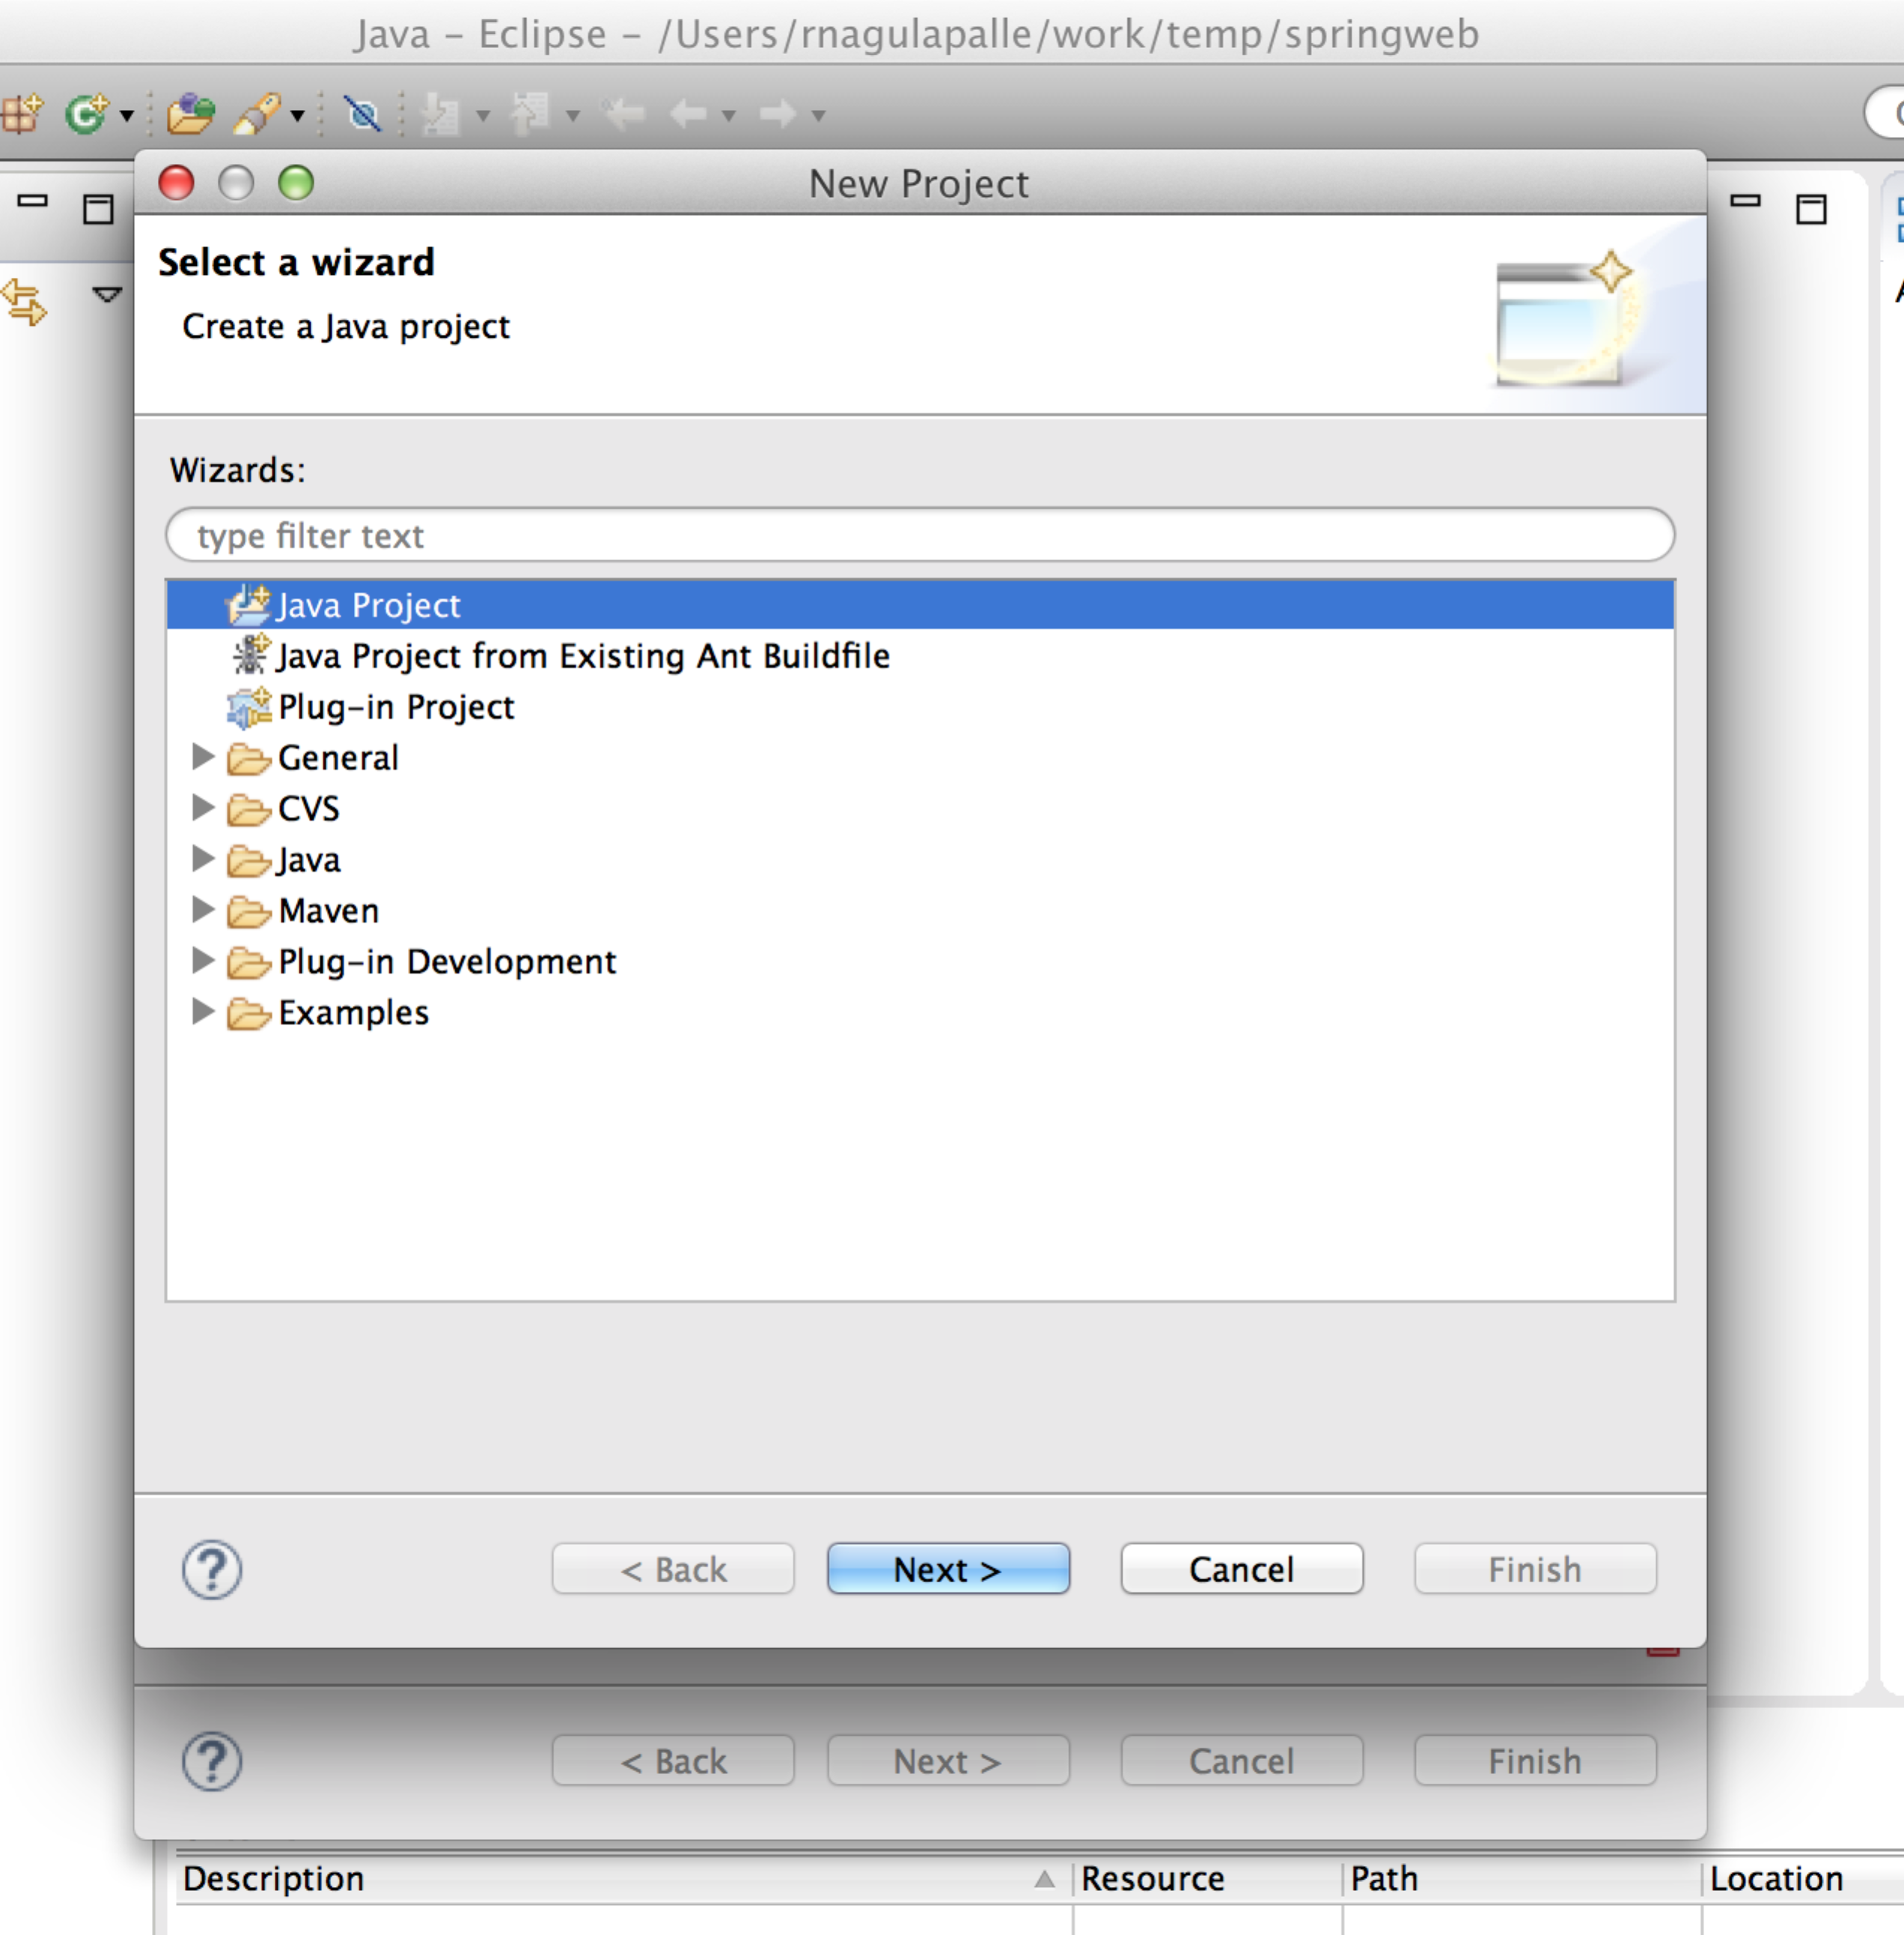
6. 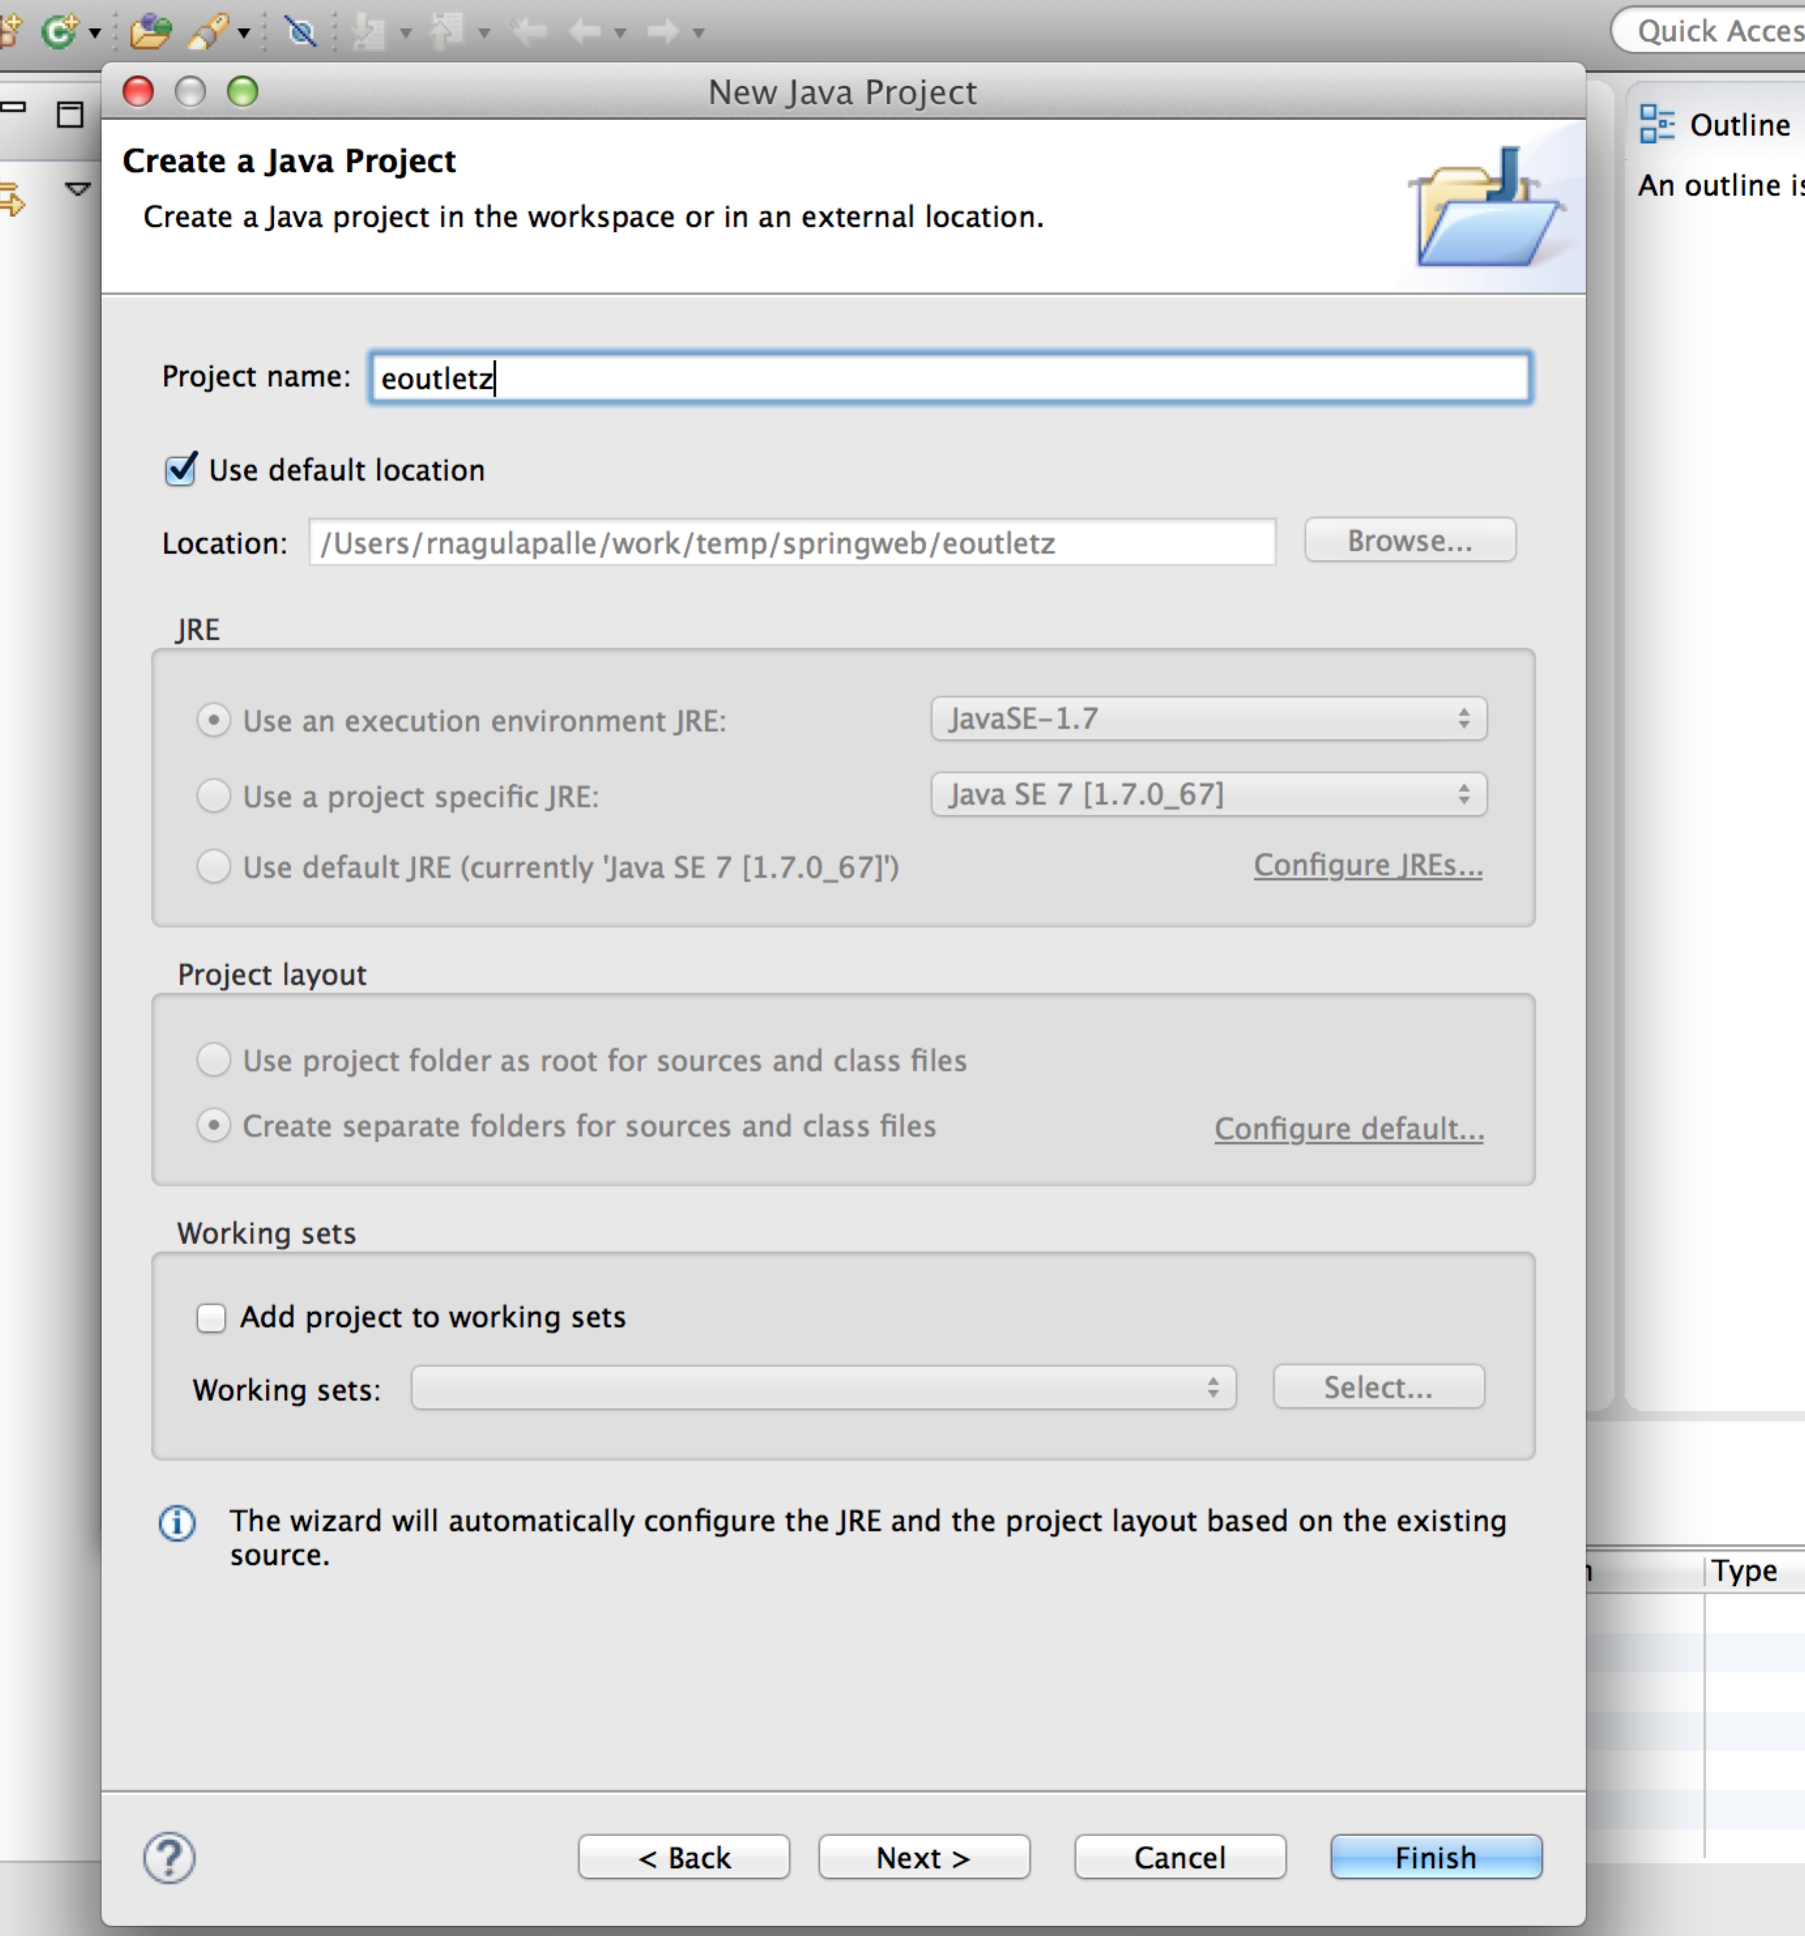
7. 